1. Introduction:
Web applications must be thoroughly planned and analyzed (just like any other serious work) prior to writing actual code. A detailed methodology of planning software applications and web ones in particular is out of this article scope, but there are four main steps to take:

- Write a detailed description of your future application from the specs provided. This description should include target users, provided functionality, knowledge required, available infrastructure, development tools, expected problems and limitations, and possible solutions.

- When you have it all written down it is easy to visualize the application if you use a flow chart. Draw the chart reading your description. Here you need to identify all the functionality modules and relationships between them in schematic way.

- Now the data flow should be obvious in your application. Translate it into a site map based on the flow chart. Draw another picture that represents all web pages in your application, their functionality, and relationships between them. A relationship could be a hyperlink, the result of a form submittal, or execution of the Response.Redirect method.

- Design your database on paper. This chart should include all tables required, fields to build up the tables, and relationships between tables. I am not going to argue with those who may say that this step could be (or even should be) taken as second one.

2. Specifications
- We intend to build a web application that implements an online storefront. This store does not require registration.
- In the store, there are three different departments offering three products types (say, TV-Video, Stereo, and Kitchen Accessories).
- The user would be able to browse the departments and view product details (e.g. description, manufacturer, price).
- At any given time, the user would be able to pick any product and place it in his/her shopping cart. The shopping cart may be viewed at any time presenting its current state (products and total cost).
- The user should be able to remove any particular item from the cart.
- Once a user decides to place an order, the application should accept user credentials (e.g. first name, last name, credit card authority, credit card number, address to deliver to), associate it with items in the user's shopping cart, and register it in a database. After the order is placed, the shopping cart is emptied.

The first is that of storing and accessing product information. The possible solutions are:
- using static HTML pages
- storing data in files and accessing it through the FileSystemObject object; with limited stored data query options
- storing data in an XML format and accessing it through the XML parser
- storing data in database and accessing it through ADO.

In this case we will choose to store data in a database and access it through ADO. With this option we can separate business logic from low level data management, and ADO also has an easy–to–use API to connect to databases and run SQL statements against it.
The next decision is that of shopping cart implementation. We could implement it in the client tier (using cookies or static frame), implement it in middle tier (using Session Object or MTS Shared Property Manager), or implement it in data tier (using temporary tables and a hidden field). The chosen solution is to implement it in client tier using cookies. I believe that if there is the opportunity to do processing on the client, thus freeing server resources, then it should be done.

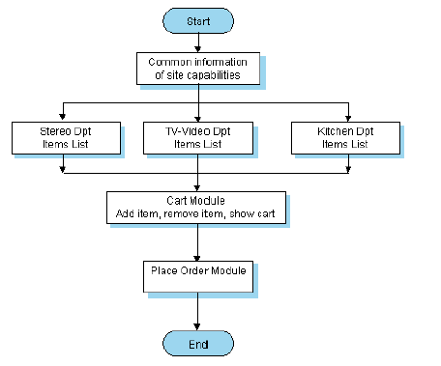
The flow chart

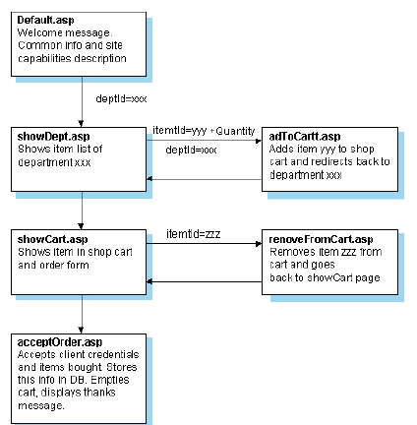
The site map

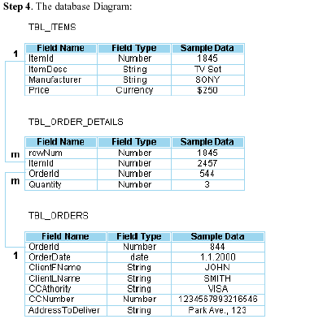
The code
We are now ready to begin coding. It would be nice to set up the database first. For our application, I am using MS Access but the data can easily be ported to SQL Server for a commercial application. After the data tier is set, let's consider the client presentation. Our first page is Default.asp which contains common info and links to our three departments: TV – Video, Stereo, and Kitchen Accessories:
Each hyperlink points to the same page, showDept.asp, but each has a different query string consisting of a deptId variable. This indicates to showDept.asp it should list items of that specific department:

<A HREF="showDept.asp?deptId=1">TV - Video</A>&nbsp;|&nbsp;
<A HREF="showDept.asp?deptId=2">Stereo</A>&nbsp;|&nbsp;
<A HREF="showDept.asp?deptId=3">Kitchen Accessories</A>

The showDept.asp page has to complete several tasks. First, it retrieves the deptId value sent in the query string to define what department was requested. Second, it builds a SQL statement to pass to the database for retrieval of items. Next, it accesses the database to retrieve records from it according to the SQL statement, and finally it sends retrieved records to our client in a manner the client can view, type in desired quantity, and add to the shopping cart:

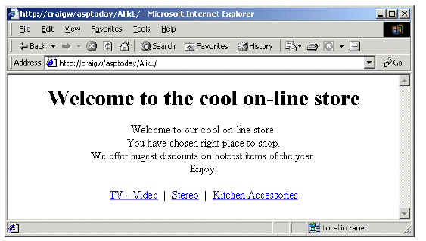
Default.asp

The default.asp
------------------------------------------------------------------------------------------------------------
<html dir="rtl">
<head>
<title>Login</title>
<meta http-equiv="Content-Type" content="text/html;charset=windows-1256"">
<head>
<title>Unauthorised Access</title>
<meta http-equiv="Content-Type" content="text/html; charset=iso-8859-1">
</head>
<body bgcolor="#FFFFFF" text="#000000">
<table width="518" border="0" cellspacing="0" cellpadding="0" align="center">
<tr>
<td align="center">
<h1>Well come to the cool online store</h1>
</td>
</tr>
</table>
<div align="center">
<h3><br>
well come to our cool online store <br>
you have chosen the right place to shop <br>
we offer largest discounts on hottest items of the year <br>
Enjoy <br>
<center>
<A HREF="showDept.asp?deptId=1">TV - Video</A>&nbsp;|&nbsp;
<A HREF="showDept.asp?deptId=2">Stereo</A>&nbsp;|&nbsp;
<A HREF="showDept.asp?deptId=3">Kitchen Accessories</A>
</center>
</div>
</body>
</html>

The showdept.asp
-----------------------------------------------------------------------------------------------------------
<html>
<head>
<title>Login</title>
<meta http-equiv="Content-Type" content="text/html;charset=windows-1256"">

<head>
<title>Unauthorised Access</title>
<meta http-equiv="Content-Type" content="text/html; charset=iso-8859-1">
</head>

<body bgcolor="#FFFFFF" text="#000000">
<center>
<A HREF="showDept.asp?deptId=1">TV - Video</A>&nbsp;|&nbsp;
<A HREF="showDept.asp?deptId=2">Stereo</A>&nbsp;|&nbsp;
<A HREF="showDept.asp?deptId=3">Kitchen Accessories</A>
</center>
<%
dptId = Request.QueryString("deptId")

arrDPT = Array("TV - Video","Stereo","Kitchen")
dptName = arrDPT(dptId - 1)

strSQL = "SELECT ID,DESC,MAN,PRICE FROM iTEMS WHERE storeID=" & dptId

dbname="\mahdy\cart.mdb"
Set conn = Server.CreateObject("ADODB.Connection")
ConnectionString="Provider=Microsoft.Jet.OLEDB.4.0;"
ConnectionString=ConnectionString & "Data Source="
ConnectionString=ConnectionString & Server.MapPath(dbname)
conn.ConnectionString =ConnectionString
conn.Open

set RS = Server.CreateObject("ADODB.recordset")
set RS=conn.Execute (strsql)

If rs.BOF And rs.EOF Then
%>
<H1>This departement is empty</H1>
<%
rs.Close
conn.Close
Set conn = Nothing
Set rs = Nothing
Response.End
End If
rs.MoveFirst
%>

<FORM action="addToCart.asp" method=POST name=form1>
<TABLE BORDER=2 CELLSPACING=1 CELLPADDING=1>
<TR>
<TH>Item</TH>
<TH>Quantity</TH>
</TR>
<%
Do Until rs.EOF
%>
<TR>
<TD><%=rs(1) & " " &rs(2)&"($"&rs(3)&")"%></TD>
<TD><INPUT name=txt<%=rs(0)%> value=<%=Request.Cookies("txt" & rs(0))%>></TD>
</TR>
<%
rs.MoveNext
Loop
%>
<TR>
<TD><INPUT type="submit" value="UPDATE CART" name=submit></TD>
<TD><INPUT type="reset" value="CLEAR" name=clear></TD>
</TR>
</TABLE>
<INPUT type="hidden" name= deptId value=<%=dptId%>>
</FORM>
<%
rs.Close
conn.Close
Set conn = Nothing
Set rs = Nothing
%>
<A HREF="showcart.asp">show cart</A>
</div>
</body>
</html>
------------------------------------------------------------------------------------------------------------
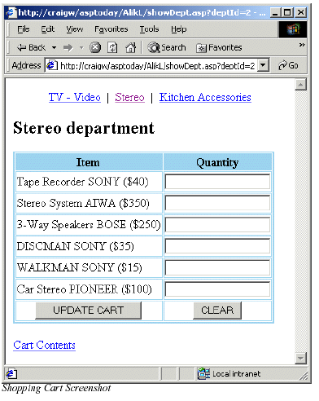

Let's look at the code. First, retrieve requested department ID:

dptId = Request.QueryString("deptId")

Let’s translate the dptId value (1,2,3) to the department name to be displayed on the page. It will help our client to navigate easily through our online store:

arrDPT = Array("TV - Video","Stereo","Kitchen")
dptName = arrDPT(dptId - 1)

Build the SQL statement:

strSQL = "SELECT ITEMID,ITEMDESC,MANUFACTURER,PRICE FROM "

strSQL= strSQL &"TBL_ITEMS WHERE DEPTID=" & dptId

Create ADO objects and access the database:
يتم التعديل طبقا لما هو شرح فى المحاضرات

Set cn = Server.CreateObject("ADODB.Connection")
Set rs = Server.CreateObject("ADODB.Recordset")
cn.Open "Provider=Microsoft.Jet.OLEDB.4.0;" _
&"Persist Security Info=False;Data Source='d:\on_line\onlinestore.mdb'"
rs.Open strSQL,cn
rs.MoveFirst

Now build a dynamic table navigating through the Recordset:

يتم كتابة هذا الجزء باى طريقة مناسبة ويمكن بدون الـ Cookies فى البداية

<FORM action="addToCart.asp" method=POST name=form1>
<TABLE BORDER=2 CELLSPACING=1 CELLPADDING=1>
<TR>
<TH>Item</TH>
<TH>Quantity</TH>
</TR>
<%
Do Until rs.EOF
%>
<TR>
<TD><%=rs(1) & " " &rs(2)&"($"&rs(3)&")"%></TD>
<TD><INPUT name=txt<%=rs(0)%> value=<%=Request.Cookies("txt" & rs(0))%>></TD>
</TR>
<%
rs.MoveNext
Loop
%>

<TR>
<TD><INPUT type="submit" value="UPDATE CART" name=submit></TD>
<TD><INPUT type="reset" value="CLEAR" name=clear></TD>
</TR>
</TABLE>
<INPUT type="hidden" name= deptIdvalue=<%=dptId%>>
</FORM>
<%
rs.Close
cn.Close
Set cn = Nothing
Set rs = Nothing
%>

I would like us to pay special attention to the highlighted line. In this line we dynamically mark text boxes with the item ID it represents by concatenating some string (here "txt") with the item ID retrieved from the database. We are going to use it in the addToCart.asp page to store the item picked and the quantity in an appropriate cookie. If a cookie of that name already exists we retrieve it to see what items and at which quantity have already been picked. We also use the hidden input type to pass department ID so that addToCart.asp will know where to return to after it has finished the cart update.

Shopping cart implementation
I have chosen to use cookies for a number of reasons. They are easy to use and code, and I believe that if there is any opportunity to pass functionality to the client it should be done, freeing resources at the server. They do have their limitations – they can only hold a small amount of data, and are easily changed by the user should they wish to do so for some reason. The shopping cart module includes three pages which each implement their own self–explanatory functionality:

addToCart.asp,showCart.asp, removeFromCart.asp.
addToCart.asp accepts the form submitted from showDept.asp,

retrieves the relevant data of item IDs and quantities that customer has chosen, stores this data in a cookie, and redirects the customer back to the same department. At this point for debugging purposes
addToCart.asp will only show us a table which contains two columns: Item ID and Quantity:

<%@ Language=VBScript %>
<HTML>
<HEAD>
</HEAD>
<BODY>
<TABLE BORDER=1 CELLSPACING=1 CELLPADDING=1>
<TR>
<TH>Item ID</TH>
<TH>Quantity</TH>
</TR>

Navigate through the Request.Form collection to retrieve relevant data:
<%
For Each item In Request.Form

Exclude values of the submit and reset buttons, and the hidden field:

If item <> "submit" And item <> "clear" And item <> "deptId"

Then process only those inputs that contain actual data:

If Request.Form(item) <> "" Then
%>
<TR>
<TD><%=mid(item,4)%></TD>
<TD><%=Request.Form(item)%></TD>
</TR>
<%
End If
End If
Next
%>
</TABLE>
</BODY>
</HTML>

The result of submitting the form that we filled in the Stereo department will look like this:

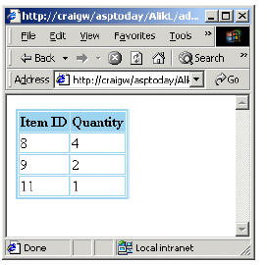

Let's put it in cookies instead of presenting it in browser, after making sure the data was passed and retrieved in a desirable way. The redesigned and final version of the addToCart.asp page will look as follows:

<%
dptID = Request.Form("deptId")
For Each item In Request.Form
If item <> "submit" And item <> "clear" And item <> "deptId" Then
If Request.Form(item) <> "" Then
Response.Cookies(item) = Request.Form(item)
End If
End If
Next
Response.Redirect "showDept.asp?deptId="&dptID
%>

---------------------------------------------------------------------------------------------------
addToCart.asp

%@ Language=VBScript %>
<HTML>
<HEAD>
</HEAD>
<BODY>
<TABLE BORDER=1 CELLSPACING=1 CELLPADDING=1>
<TR>
<TH>Item ID</TH>
<TH>Quantity</TH>
</TR>

<%
For Each item In Request.Form
If item <> "submit" And item <> "clear" And item <> "deptId" then
If Request.Form(item) <> "" Then
%>
<TR>
<TD><%=mid(item,4)%></TD>
<TD><%=Request.Form(item)%></TD>
</TR>
<%
End If
End If
Next
%>
<%
dptID = Request.Form("deptId")
For Each item In Request.Form
If item <> "submit" And item <> "clear" And item <> "deptId" Then
If Request.Form(item) <> "" Then
Response.Cookies(item) = Request.Form(item)
End If
End If
Next
Response.Redirect "showDept.asp?deptId="&dptID
%>

</TABLE>
</BODY>
</HTML>
---------------------------------------------------------------------------------------------------

Now let's provide the ability to view the cart contents by building the showCart.asp page. To do so we need to navigate through the Request.Cookies collection and retrieve all relevant cookies. Relevant cookies are those that have names starting with txt (we could give any other name, like "basket" for example):

<TABLE BORDER=1 CELLSPACING=1 CELLPADDING=1>
<TR>
<TH>Item ID</TH>
<TH>Quantity</TH>
<TH>Remove</TH>
</TR>
<%

Navigate through Request.Cookies collection:

For Each item In Request.Cookies

Recognize relevant cookie:
If Left(item,3) = "txt"

Then retrieve the actual item ID:

itemId=Mid(item,4)%><TR>
<TD><%=itemId%></TD>
<TD><%=Request.Cookies(item)%></TD><TD><A
HREF="removeFromCart.asp?cook=<%=item%>">Remove Now</A></TD>
</TR>
<%
End If
Next
%>
</TABLE>

As you can see, each row in the table is built up of the item ID, its quantity, and a hyperlink to the removeFromCart.asp page which passes the cookie name (txt15, for example) in a query string to remove it from the shopping cart:

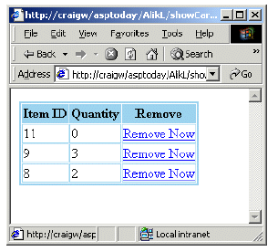

Works fine, but item ID won't say much to our customer. It does link however to the TBL_ITEMS table which contains all the item information we need. So in order to present to the customer a comprehensible representation of their shopping cart we need to access the database to retrieve the information about items in their cart. Let's redesign showCart.asp. First we build the SQL statement to retrieve the data:

<%
strSQL = "SELECT * FROM TBL_ITEMS WHERE ITEM_ID IN("
For Each item In Request.Cookies
If Left(item,3) = "txt" Then
itemId = Mid(item,4)
strSQL = strSQL & itemId & ","
End If
Next
strSQL = strSQL & "-1)"
%>

When the SQL statement is ready to run we create the ADO objects and retrieve data into the Recordset Object, and then just show it to a client navigating through the records:

<%
Set cn = Server.CreateObject("ADODB.Connection")
Set rs = Server.CreateObject("ADODB.Recordset")
cn.Open "Provider=Microsoft.Jet.OLEDB.4.0;" _
&"Persist Security Info=False;Data Source='d:\on_line\onlinestore.mdb'"
rs.Open strSQL,cn
It could be very helpful to check if there is anything in the cart, if not display an appropriate message to client:

If rs.BOF And rs.EOF Then
%>
<H1>Your Cart Is Empty</H1>
<%
rs.Close
cn.Close
Set cn = Nothing
Set rs = Nothing
Response.End
End If

If the cart is not empty, show its contents:

rs.MoveFirst
%>
<H2>Items List In Shopping Cart:</H2>
<TABLE BORDER=1 CELLSPACING=1 CELLPADDING=1>
<TR>
<TH>Item</TH>
<TH>Quantity</TH>
<TH>Remove</TH>
</TR>
<%
Do Until rs.EOF
item = "txt" & rs(0)
quantity = Request.Cookies(item)
totalCost = totalCost + rs(3) * quantity
%>
<TR>
<TD><% = rs(1) & " " & rs(2) & " ($" & rs(3) & ")"%></TD>
<TD><% = quantity%></TD>

Providing a hyperlink to removeFromCart.asp makes it possible to remove specific items from the cart. This hyperlink should also pass the name of the item to be removed using a query string

<TD>
<A \HREF="removeFromCart.asp?cook=<%=item%>">RemoveNow</A>
</TD>
</TR>
<%
rs.MoveNext
Loop
rs.Close cn.Close Set
cn = Nothing Set
rs = Nothing
%>
</TABLE>
<H3>total Cost :$<%=totalCost%></H3>
The new look of our shopping cart is much nicer than before:

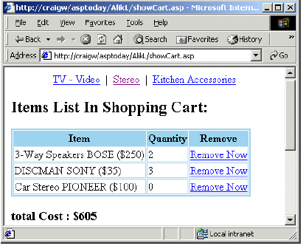

showcart.asp
---------------------------------------------------------------------------------------------------
<%@ Language=VBScript %>
<HTML>
<HEAD>
</HEAD>
<BODY>
<center>
<A HREF="showDept.asp?deptId=1">TV - Video</A>&nbsp;|&nbsp;
<A HREF="showDept.asp?deptId=2">Stereo</A>&nbsp;|&nbsp;
<A HREF="showDept.asp?deptId=3">Kitchen Accessories</A>
</center>
<%
strSQL = "SELECT * FROM ITEMS WHERE ID IN("
For Each item In Request.Cookies
If Left(item,3) = "txt" Then
itemId = Mid(item,4)
strSQL = strSQL & itemId & ","
End If
Next
strSQL = strSQL & "-1)"
%>

<%
dbname="\mahdy\cart.mdb"
Set conn = Server.CreateObject("ADODB.Connection")
ConnectionString="Provider=Microsoft.Jet.OLEDB.4.0;"
ConnectionString=ConnectionString & "Data Source="
ConnectionString=ConnectionString & Server.MapPath(dbname)
conn.ConnectionString =ConnectionString
conn.Open

set RS = Server.CreateObject("ADODB.recordset")
set RS=conn.Execute (strsql)

If rs.BOF And rs.EOF Then
%>
<H1>Your Cart Is Empty</H1>
<%
rs.Close
conn.Close
Set conn = Nothing
Set rs = Nothing
Response.End
End If

rs.MoveFirst
%>
<H2>Items List In Shopping Cart:</H2>
<TABLE BORDER=1 CELLSPACING=1 CELLPADDING=1>
<TR>
<TH>Item</TH>
<TH>Quantity</TH>
<TH>Remove</TH>
</TR>
<%
Do Until rs.EOF
item = "txt" & rs(0)
quantity = Request.Cookies(item)
totalCost = totalCost + rs(3) * quantity
%>
<TR>
<TD><% = rs(1) & " " & rs(2) & " ($" & rs(3) & ")"%></TD>
<TD><% = quantity%></TD>

<TD>
<A HREF="removeFromCart.asp?cook=<%=item%>">RemoveNow</A>
</TD>
</TR>
<%
rs.MoveNext
Loop

rs.Close
conn.Close
Set conn = Nothing
Set rs = Nothing
%>
</TABLE>
<H3>total Cost :$<%=totalCost%></H3>

<P align=center>
<FORM action="acceptOrder.asp" method=POST name=form1>
<TABLE BORDER=1 CELLSPACING=1 CELLPADDING=1>
<TR>
<TD>First Name</TD>
<TD><INPUT name=txtFName></TD>
</TR>
<TR>
<TD>Last Name</TD>
<TD><INPUT name=txtLName></TD>
</TR>
<TR>
<TD>CreditCard Authority</TD>
<TD><INPUT name=txtCCAuth>
</TD>
</TR>
<TR>
<TD>Credit CardNumber</TD>
<TD><INPUT name=txtCCNum></TD>
</TR>
<TR>
<TD>AddressTo Deliver</TD>
<TD><INPUT name=txtAddr></TD>
</TR>
<TR>
<TD><INPUT type="submit" value = "Make Order"></TD>
<TD><INPUT type="reset" value="Clear"></TD>
</TR>
</TABLE>
</FORM>
</P>
</BODY>
</HTML>
---------------------------------------------------------------------------------------------------

The last thing to do in the shopping cart module is to build a removeFromCart.asp page. This page accepts a cookie name representing the item to be removed from the shopping cart. All we need to do is retrieve this name from query string, set the expiration date to a time in the past for this cookie (which deletes the cookie), and return to the shopping cart:

<%
cookName = Request.QueryString("cook")
Response.Cookies(cookName).Expires = Now()-1000
Response.Redirect "showCart.asp"
%>

removeFromCart.asp:
--------------------------------------------------------------------------------------------------
<%@ Language=VBScript %>
<HTML>
<HEAD>
</HEAD>
<BODY>
<center>
<A HREF="showDept.asp?deptId=1">TV - Video</A>&nbsp;|&nbsp;
<A HREF="showDept.asp?deptId=2">Stereo</A>&nbsp;|&nbsp;
<A HREF="showDept.asp?deptId=3">Kitchen Accessories</A>
</center>
<%
cookName = Request.QueryString("cook")
Response.Cookies(cookName).Expires = Now()-1000
Response.Redirect "showCart.asp"
%>
</BODY>
</HTML>
--------------------------------------------------------------------

Accepting the order

One last thing left to do is to accept the order. For that purpose, we are going to provide a form in showCart.asp to accept the client data. This form will be processed by the acceptOrder.asp page. Here is the additional code for showCart.asp that displays the order form:

<P align=center>
<FORM action="acceptOrder.asp" method=POST name=form1>
<TABLE BORDER=1 CELLSPACING=1 CELLPADDING=1>
<TR>
<TD>First Name</TD>
<TD><INPUT name=txtFName></TD>
</TR>
<TR>
<TD>Last Name</TD>
<TD><INPUT name=txtLName></TD>
</TR>
<TR>
<TD>CreditCard Authority</TD>
<TD><INPUT name=txtCCAuth>
</TD>
</TR>
<TR>
<TD>Credit CardNumber</TD>
<TD><INPUT name=txtCCNum></TD>
</TR>
<TR>
<TD>AddressTo Deliver</TD>
<TD><INPUT name=txtAddr></TD>
</TR>
<TR>
<TD><INPUT type="submit" value = "Make Order"></TD>
<TD><INPUT type="reset" value="Clear"></TD>
</TR>
</TABLE>
</FORM>
</P>

The code above results in the following presentation:

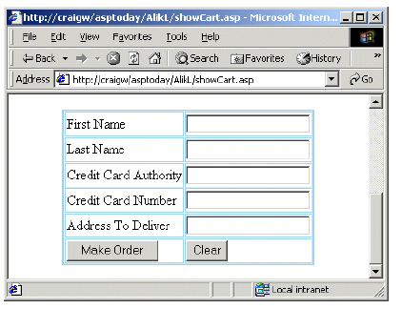
The acceptOrder.asp page accepts the data sent by the form and stores it in the TBL_ORDERS table, assigning a unique ID to the ORDERID field of the new record. After that, it stores all shopping cart items in TBL_ORDER_DETAILS assigning to the ORDERID field the very same unique ID. The question is, where do we get this unique ID? The simplest answer seems to be to manage a single row, single field table that will store this unique ID. Every time that we will need a new unique value, we'll just update the current value by increasing it by one. The following is the acceptOrder.asp page:

Retrieve Form data submitted by user:
<%
fn = Request.Form("txtFName")
ln = Request.Form("txtLName")
cca = Request.Form("txtCCAuth")
ccn = Request.Form("txtCCNum")
addr = Request.Form("txtAddr")

Build SQL statement to retrieve unique ID for the order:

strSQLUniqueValue = "SELECT * FROM TBL_COUNTER"
Create ADO objects, retrieve unique ID, and increase it by one:
Set cn = Server.CreateObject("ADODB.Connection")
Set rs = Server.CreateObject("ADODB.Recordset")
cn.Open "Provider=Microsoft.Jet.OLEDB.4.0;Persist Security Info=False;" & _
"Data Source='d:\on_line\onlinestore.mdb'"

Don't forget to set the recordset lock type property to 2 (pessimistic lock type) so it will be updateable:

rs.Open strSQLUniqueValue,cn,,2
thisOrderNumber = rs(0)
rs(0) = thisOrderNumber+1
rs.Update
rs.Close
Set rs = Nothing

Build SQL statement to make new record in TBL_ORDERS table and execute it:

strSQLNewOrder = "INSERT INTO TBL_ORDERS " _
&"(ORDERID,ORDERDATE,CLIENTFNAME," _
&"CLIENTLNAME,CCAUTHORITY,CCNUMBER,ADDRESSTODELIVER)" _
&"VALUES(" & thisOrderNumber & ",#" & Now() & "#,'"_
& fn & "','" & ln & "','" & cca & "'," & ccn & ",'" & addr & "')"
cn.Execute strSQLNewOrder

Now, navigate through the Request.Cookies collection using a For Each loop. Inside the loop build a SQL statement for each item in the shopping cart and execute it to insert it into the TBL_ORDER_DETAILS table:

For Each item In Request.Cookies
If Left(item,3) = "txt" Then
itemId = Mid(item,4)
quantity = Request.Cookies(item)
strSQLOrderDetails="INSERT INTO TBL_ORDER_DETAILS " _
&"(ITEMID,ORDERID,QUANTITY)VALUES(" _
& itemId & "," & thisOrderNumber & "," & quantity & ")"
cn.Execute strSQLOrderDetails

Empty each item from the cart after updating the database:

Response.Cookies(item).Expires = Now()-1000
End If
Next
cn.Close
Set cn = Nothing
%>

Display a friendly message to client:

<HTML>
<HEAD></HEAD>
<BODY>
<H2 align = center> Your Order Was Successfully Accepted. Order Number is:
<%=thisOrderNumber%></H2>
</BODY></HTML>

acceptOrder.asp
---------------------------------------------------------------------------------------------------
<%@ Language=VBScript %>
<HTML>
<HEAD>
</HEAD>
<BODY>
<center>
<A HREF="showDept.asp?deptId=1">TV - Video</A>&nbsp;|&nbsp;
<A HREF="showDept.asp?deptId=2">Stereo</A>&nbsp;|&nbsp;
<A HREF="showDept.asp?deptId=3">Kitchen Accessories</A>
</center>
<%
fn = Request.Form("txtFName")
ln = Request.Form("txtLName")
cca = Request.Form("txtCCAuth")
ccn = Request.Form("txtCCNum")
addr = Request.Form("txtAddr")

strSQL= "SELECT * FROM count"

dbname="\mahdy\cart.mdb"
Set conn = Server.CreateObject("ADODB.Connection")
ConnectionString="Provider=Microsoft.Jet.OLEDB.4.0;"
ConnectionString=ConnectionString & "Data Source="
ConnectionString=ConnectionString & Server.MapPath(dbname)
conn.ConnectionString =ConnectionString
conn.Open

set RS = Server.CreateObject("ADODB.recordset")
rs.Open "select * from counts",conn,,2

thisOrderNumber = rs(0)
rs(0) = thisOrderNumber+1
rs.Update
rs.Close
Set rs = Nothing

mydate=now()
mydate1=split(mydate," ")

strSQL = "INSERT INTO orders (id,orderdate,fname,lname,cardtype,cnumber,address) VALUES ( "
strsql=strsql & thisOrderNumber & ",#" & mydate1(0) & "#,'"
strSQL=strSQL & fn & "','" & ln & "','" & cca & "'," & ccn & ",'" & addr & "' )"

response.write strsql
//response.end

conn.execute (strsql)

For Each item In Request.Cookies
If Left(item,3) = "txt" Then
itemId = Mid(item,4)
quantity = Request.Cookies(item)

strSQLOrderDetails="INSERT INTO order_detail (ITEMID,ORDERID,QUANTITY) VALUES ("
strSQLOrderDetails=strSQLOrderDetails & itemId & "," & thisOrderNumber & "," & quantity & ")"
conn.Execute strSQLOrderDetails

Response.Cookies(item).Expires = Now()-1000
End If
Next
conn.Close
Set conn = Nothing
%>

<HTML>
<HEAD></HEAD>
<BODY>
<H2 align = center> Your Order Was Successfully Accepted. Order Number is:
<%=thisOrderNumber%></H2>
</BODY></HTML>
------------------------------------------------------------------------
Conclusion
I have covered a simplified development process for a data driven web commerce application utilizing all three tiers: presentation, business, and data. In addition, we've seen one of the many possible realizations of a shopping cart based on cookies. It has its pros: it is easy to implement, it utilizes client resources, and it is fast. It also has its cons: the browser accepts a limited number of cookies or it may not accept cookies at all. This can be checked by ASP code and if it does not we can display a friendly message like: "Our site requires cookies to be enabled. Please enable them, and you will be able to enjoy our huge discounts…" There are still a lot things to take care of like form validation, credit card verification, preventing duplicated orders, providing transactional support, security, etc. that we haven’t covered here – it is not possible to learn how to build an entire commercial application from just one article! This sample application should be taken more as
a starting point.

